**Project Design Phase-II**

**Technology Stack (Architecture & Stack)**

|  |  |
| --- | --- |
| Date | 26-june-2025 |
| Team ID | LTVIP2025TMID30428 |
| Project Name | To supply left over food to poor |
| Maximum Marks | 2 Marks |

**Technical Architecture:**

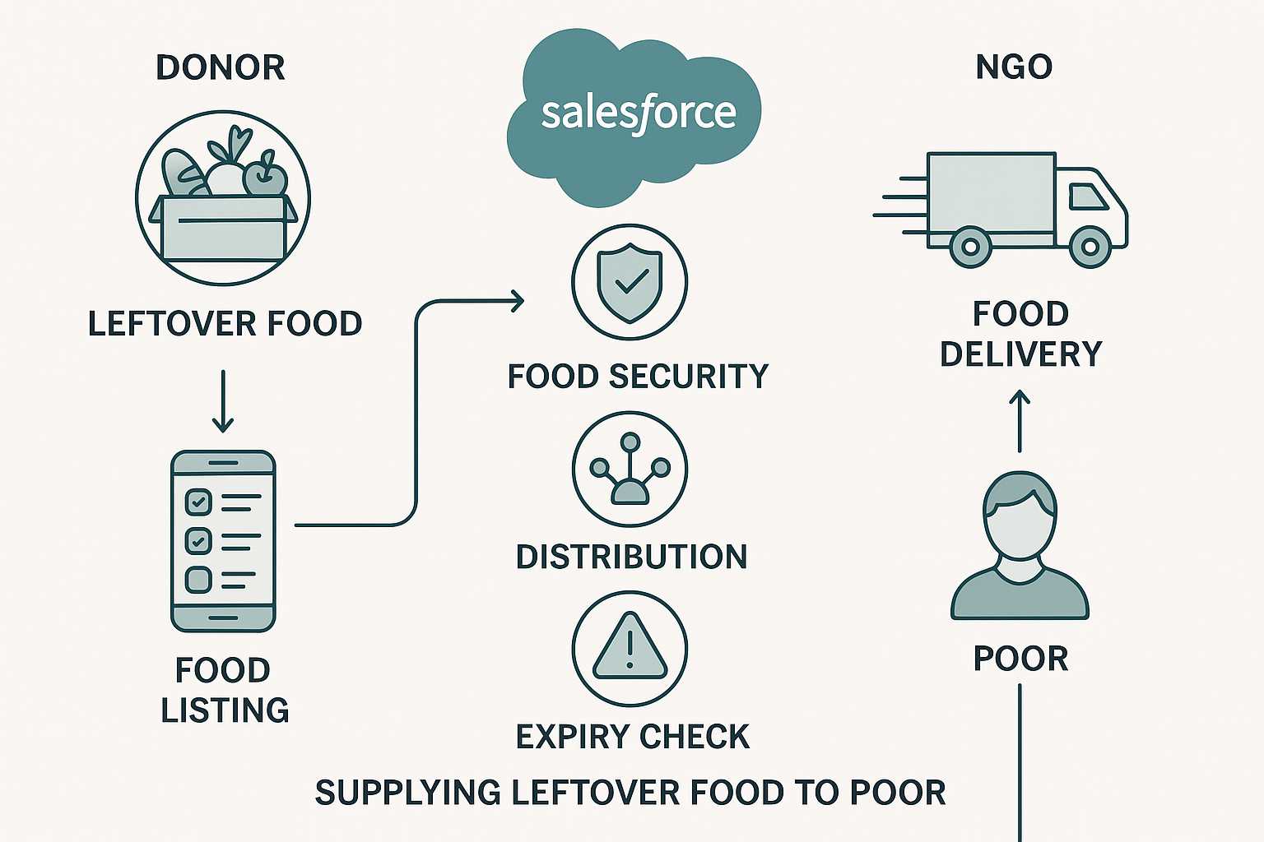

**Table-1 : Components & Technologies:**

| **S.No** | **Component** | **Description** | **Technology** |
| --- | --- | --- | --- |
| **1** | **User Interface** | **Web and Mobile App Interface** | **Salesforce Lightning, Mobile App, HTML, CSS** |
| **2** | **Application Logic-1** | **Food registration and listing** | **Apex (Salesforce backend)** |
| **3** | **Application Logic-2** | **Pickup assignment and tracking** | **Apex + Process Builder + Flows** |
| **4** | **Application Logic-3** | **Notifications & Reminders** | **Salesforce Flows + Email Services** |
| **5** | **Database** | **Stores food data, user data, pickup logs** | **Salesforce Standard Objects + Custom Objects** |
| **6** | **Cloud Database** | **Cloud-based CRM and object data** | **Salesforce Platform Cloud** |
| **7** | **File Storage** | **Food images and delivery proofs** | **Salesforce Files** |
| **8** | **External API-1** | **Address Geolocation** | **Google Maps API** |
| **9** | **External API-2** | **SMS Notification** | **Twilio API** |
| **10** | **Machine Learning Model** | **Predict food demand (future scope)** | **Not implemented (future use: Einstein AI)** |
| **11** | **Infrastructure** | **Hosted on Salesforce Cloud** | **Salesforce Cloud Platform** |

**Table-2: Application Characteristics:**

| **S.No** | **Characteristics** | **Description** | **Technology / Tools Used** |
| --- | --- | --- | --- |
| **1** | **Open-Source Frameworks** | **None (Built on Salesforce cloud tools)** | **N/A** |
| **2** | **Security Implementations** | **Role-based access, encrypted data, OAuth2** | **Salesforce Shield, OAuth2** |
| **3** | **Scalable Architecture** | **Scales via Salesforce multitenant architecture** | **Salesforce Platform Architecture** |
| **4** | **Availability** | **99.9% uptime via Salesforce cloud** | **Salesforce Load Balanced Cloud Servers** |
| **5** | **Performance** | **Caching using Lightning framework; optimized flow performance** | **Salesforce Performance Edition + CDN (if web)** |